Name
Institution
Date
Transmission genetics established by Mendel agrees with DNA principle of heredity

Introduction
Gregor Mendel is known as the genetic father. He was the first person to demonstrate characters transmission mechanisms from one generation to the other. The term heredity refers to the sum of the biological processes through which there is the transmission of particular characteristics to the offspring from the parents. Mendel established the transmission genetics in that in his work he deducted that it is in pairs that genes come and as distinct units, they are established, one from each parent. Mendel observed that there is the inheritance of traits as alternate states of independent units' inheritance or genes. When it comes to the DNA it, therefore, becomes a genetic material because of the structural features. One of the features is that the genetic material must be able to store information, replicate, allow mutation variation and be able to express information. The genetic material must be transmitted to the offspring from the parent physically. The DNA structure is closely related to the genetic code is a genetic material. The term genetic code refers to a set of rules by which in the genetic material information encoded is translated by living cells into proteins. What this code defines specifically is a mapping between codons and amino acids which are sequences that are tri-nucleotide. “The genetic code, therefore, becomes identical in almost all species.” (Watson, Berry, 2009)
Discussion
Genes are passed from parents to infants. Therefore there must be arrangements of the DNA when genes are being transferred. According to Mendel, there are laws which determine how the genes are transferred and they form the basis of arrangements. This was a mathematical pattern of inheritance. One of the first arrangement is based on the Law of Segregation. The law states that a gene pair defines each inherited trait. There is randomly separation of parental genes to the sex cells so that only one gene of the pair is what the sex cells contain. Therefore from each parent-offspring inherit one genetic allele when in the process of fertilization sex cells unite. The other arrangement is based on the Law of Independent Assortment. What it entails is that during the transfer of genes for different traits, they are separately sorted from one another. Therefore there is no dependence on one trait during the inheritance on the other. The third arrangement of DNA during genes transfer is based on the Law of Dominance. “When it comes to the law of dominance what it entails is that a dominant form will be expressed by an organism with forms of a gene that are alternate.” (Carlson, 2004)
Most genes when it comes to transferring are either dominant or recessive. This is because different phenotypic effects are exerted by different alleles. If for example by the combinations of AA and AB is when phenotypes are produced what will be the outcome is that A will be dominant to B or in controversy B will be recessive to A. When a stronger effect is not exerted by either of them, what will be resulted is a codominant and to the offspring the phenotypic features will be shown .This is what is in the case of an individual with type AB blood. “They have blood BB and AA blood groups features.” (Avise, 2014)

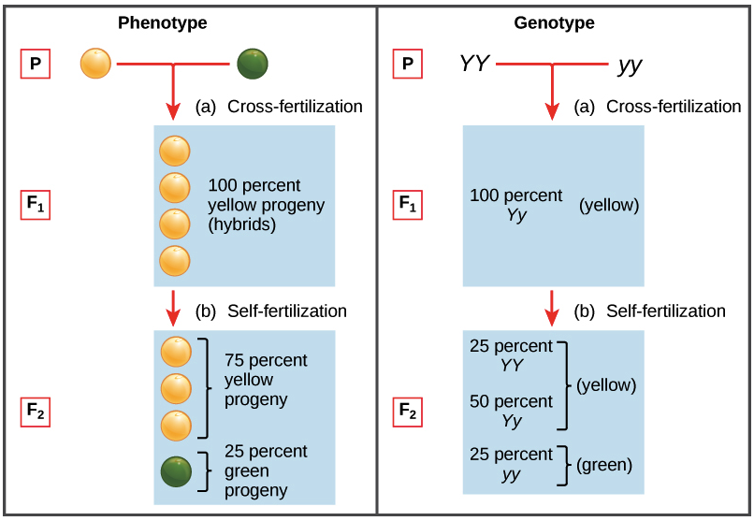
The figure above shows an explanation by Mendel on how parents’ traits determine offspring traits

History of experiments and observations
Knowledge of genetic mechanisms came as a result of laboratory breeding experiments that over the last and a half-century were carried out. The genetics focus shifted to understanding what really happens in hereditary traits transmission to children from parents. Gregor Mendel, in explaining hereditary suggested a number of hypotheses. Doing basic genetics research is what his early adult life was spent on. Mendel research was with plants. He discovered that he could apply to people the basic underlying heredity principles. This is because heredity mechanisms for all complex life forms are the same essentially. What Mendel discovered was that there was showing of certain traits in offspring without any parent characteristics blending through common pes plans cross-breeding. The pea flowers, for instance, are either white or purple in the offspring of pea plants that are cross-pollinated, intermediate colours do not appear. The observation was critically important because in biology the leading theory was that from generation to generation inherited traits blend. Common garden pea plants were picked by Mendel for his research because in large numbers they can be easily grown and their reproduction manipulated. Mendel in his experiments was able to cross-pollinate purebred plants selectively with particular traits and over many generations, observe the outcome. “About the genetic inheritance nature, this was his conclusions basis.” (Watson, Berry, 2009)

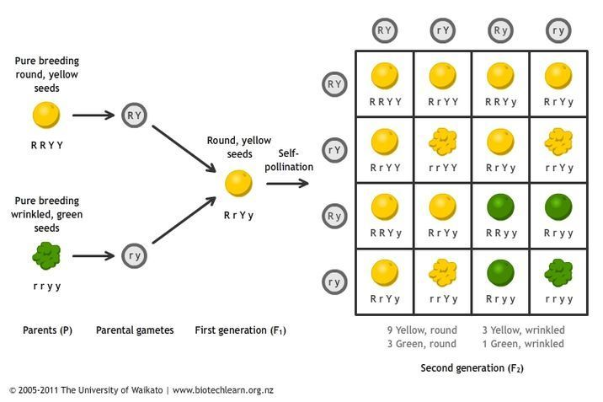
The above figure shows Mendel’s explanation of inheritance from a pea single trait in explaining his ideas

Mendel came with three important conclusions after the results of his experiments.
1. Units or factors determine each trait inheritance that on to unchanged descendants are passed. Genes are now what these units are called.
2. There can be passing of a trait on to the next generation even if it did not show up in an individual
3. It is from each parent for each trait that individuals inherit them
The experiments can be summarized through the principle of independent assortment and the principle of segregation which I have discussed in the in the discussion area. The two principles along with the unit of dominance and inheritance understanding were the beginning of the genetics of modern science. However, for his contributions, Mendel gets credit rarely because there remained unknown essentially of his work. This was until ideas by Lamarck's were rejected as being impossible widely.
Examples showing genetics of inherited traits
Traits refer to features or characteristics that from one generation to another can be passed. Some of these traits include skin colour, size, hair colour etc. Other traits may include how a person is optimistic, feeling more negative or negative about emotions, how motivated a person is when it comes to social approval seeking, how intensively a person shows emotions etc. When it comes to our complex personality these traits are the main basis. They tell about individual natural reactions in the continuum of traits. Some people are usually harmed by stress more or punishments that are severed than others. It is usually the genes that make them be more sensitive when it comes to factors environment.
When it comes to our mental abilities, genes are a big part as well. Together with an environment that is supportive, a lot of practice and resources they are part of giftedness origin.
Conclusion
Indeed many organisms show similar inheritance patterns to the seminal ones as Mendel described in the pea. The inheritance principles that Mendel developed have had a greater impact in understanding how transmission genetics agree with the DNA principle of hereditary. Scientists up to this day use Mendel knowledge in explaining inheritance most basic phenomena (Avise, 2014)

References
Watson, J. D., & Berry, A. (2009). DNA: The secret of life. New York: Knopf.
Avise, J. C. (2014). Conceptual Breakthroughs in Evolutionary Genetics: A Brief History of Shifting Paradigms.
Acquaah, G. (2012). Principles of plant genetics and breeding.
Ginsburg, E., Malkin, I., & Elston, R. C. (2006). Theoretical aspects of pedigree analysis
Carlson, E. A. (2004). Mendel's legacy: : the origins of classical genetics. New York (N.Y.: Cold Spring Harbor Laboratory Press.

